Supplementary Material for: Upper mantle slab under Alaska: contribution to anomalous core-phase observations on south-Sandwich to Alaska paths
Authors: Daniel A. Frost¹*, Barbara Romanowicz^{1,2,3}, Steve Roecker⁴

Contains 8 supplementary figures, and 3 supplementary tables.

Supplementary Figures

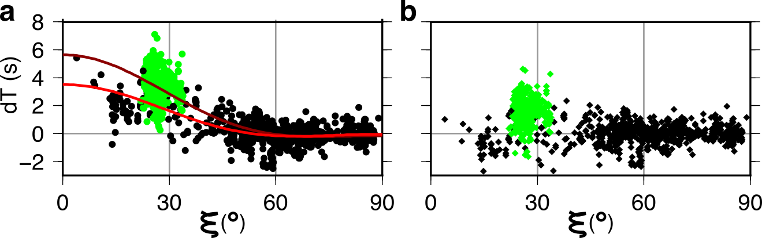

Supplementary Figure 1. PKPab-df and PKPbc-df travel time anomalies as a function of ξ, the angle of the path relative to the rotation axis, showing only data turning in the upper 450 km of the western hemisphere of the inner core. Data from the South Sandwich Islands to Alaska path are shown in green, while all other data is shown in black. (a) Observed travel time anomalies showing the fits to equation S1 using all data (dark red) and only data from outside of the South Sandwich Islands to Alaska path (red). (b) Data corrected for the red model in a.

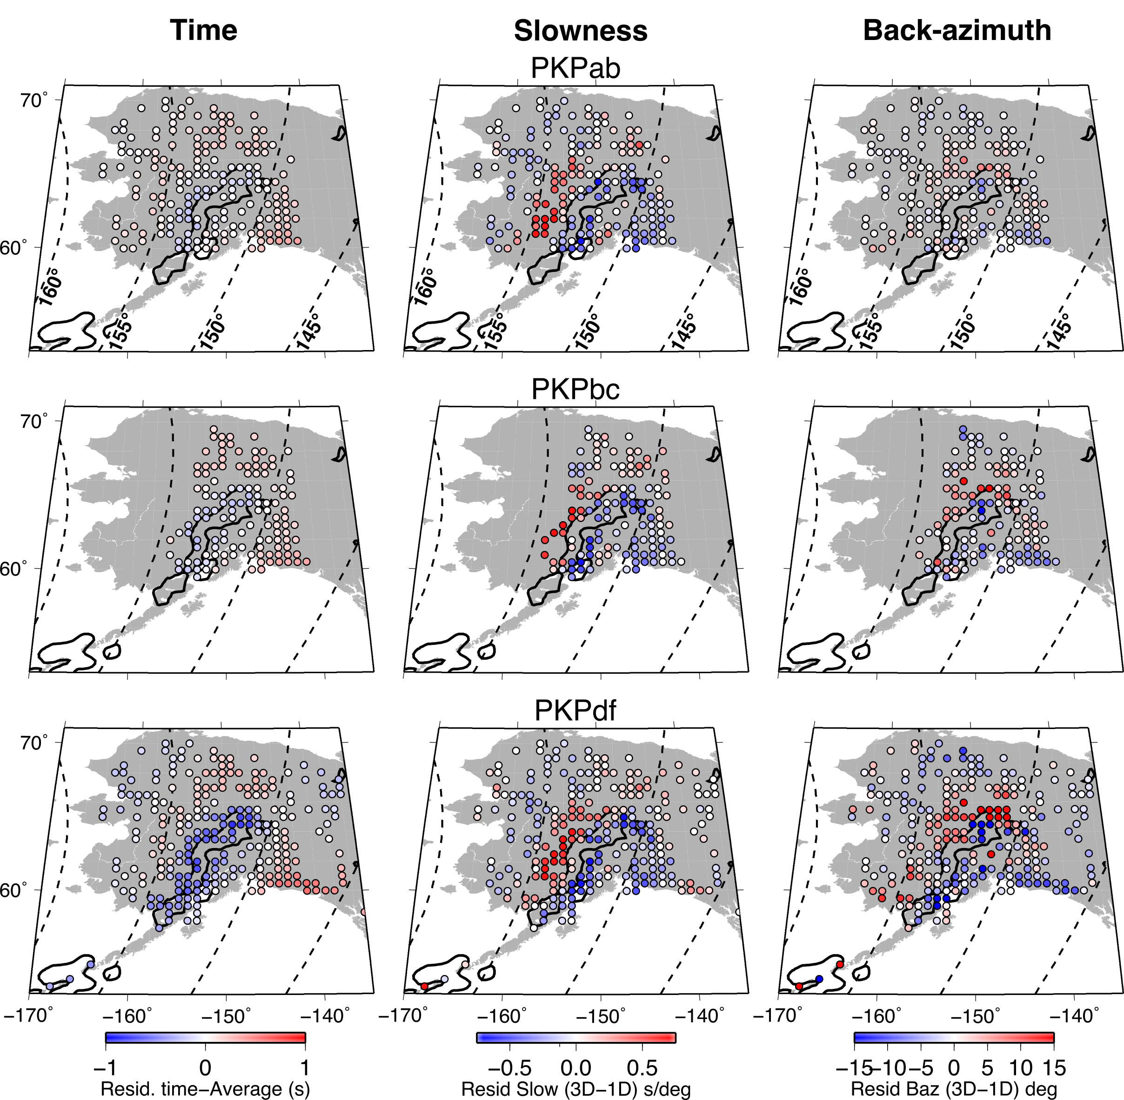
Supplementary Figure 2: Predicted ray anomalies for (top) PKPab, (middle) PKPbc, and (bottom) PKPdf from 3D ray-tracing through our preliminary tomography model of Alaska, for all 6 events. (left) Travel time residuals. (centre) Slowness residuals. (right) Back-azimuth residuals. The outline of the Alaskan slab at 200 km depth (+0.8% dVp) from the preliminary tomography model is shown in black.

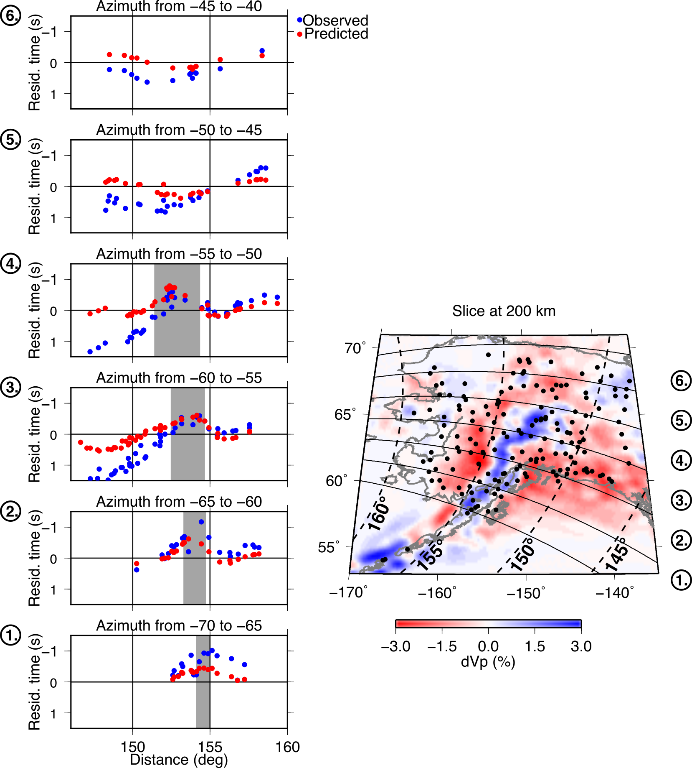
Supplementary Figure 3: Left: Absolute PKPdf travel time anomalies as a function of distance and for different sections through the slab for event 6 on 2018-12-11. Observations are shown in blue and predictions from 3D ray-tracing through the tomography model (as in Figure 3) are shown in red. Note that increasing distance means moving across section from southeast to northwest. The rough location of the slab in each cross section is marked by grey shading. Right: Map of the upper mantle tomography model at 200 km depth, with stations shown as black circles. Azimuths sections shown on the left are labelled on the right, and diamonds show distances along the section.

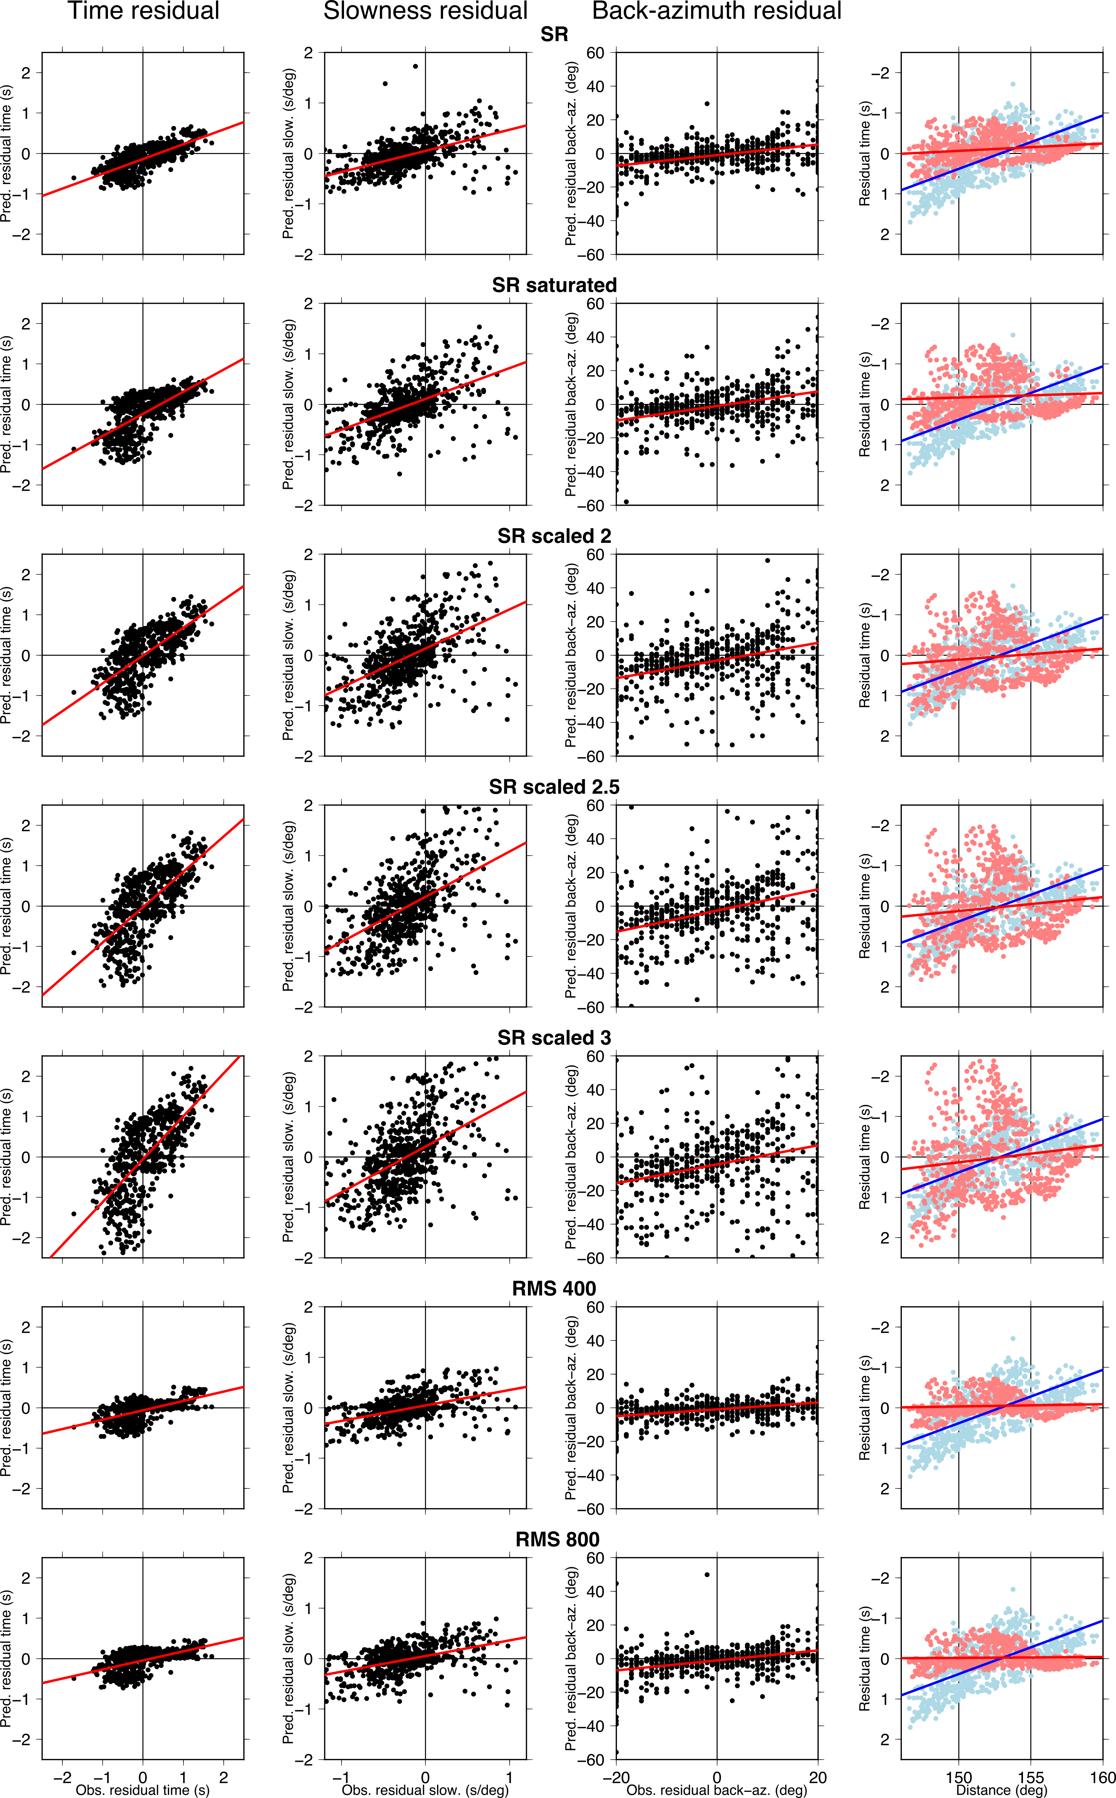
Supplementary Figure 4: Comparison of absolute PKPdf ray anomalies from 3D ray-tracing through standard and perturbed versions of our preliminary tomography model of Alaska, for all 6 events listed in Suppl. Table 2. (Column 1) travel time residuals, (Column 2) slowness residuals, (Column 3) back-azimuth residuals, and (Column 4) travel time residuals as a function of distance from the source showing observations (blue) and predictions (red). Models and fits correspond to those in Supplementary Table 2.

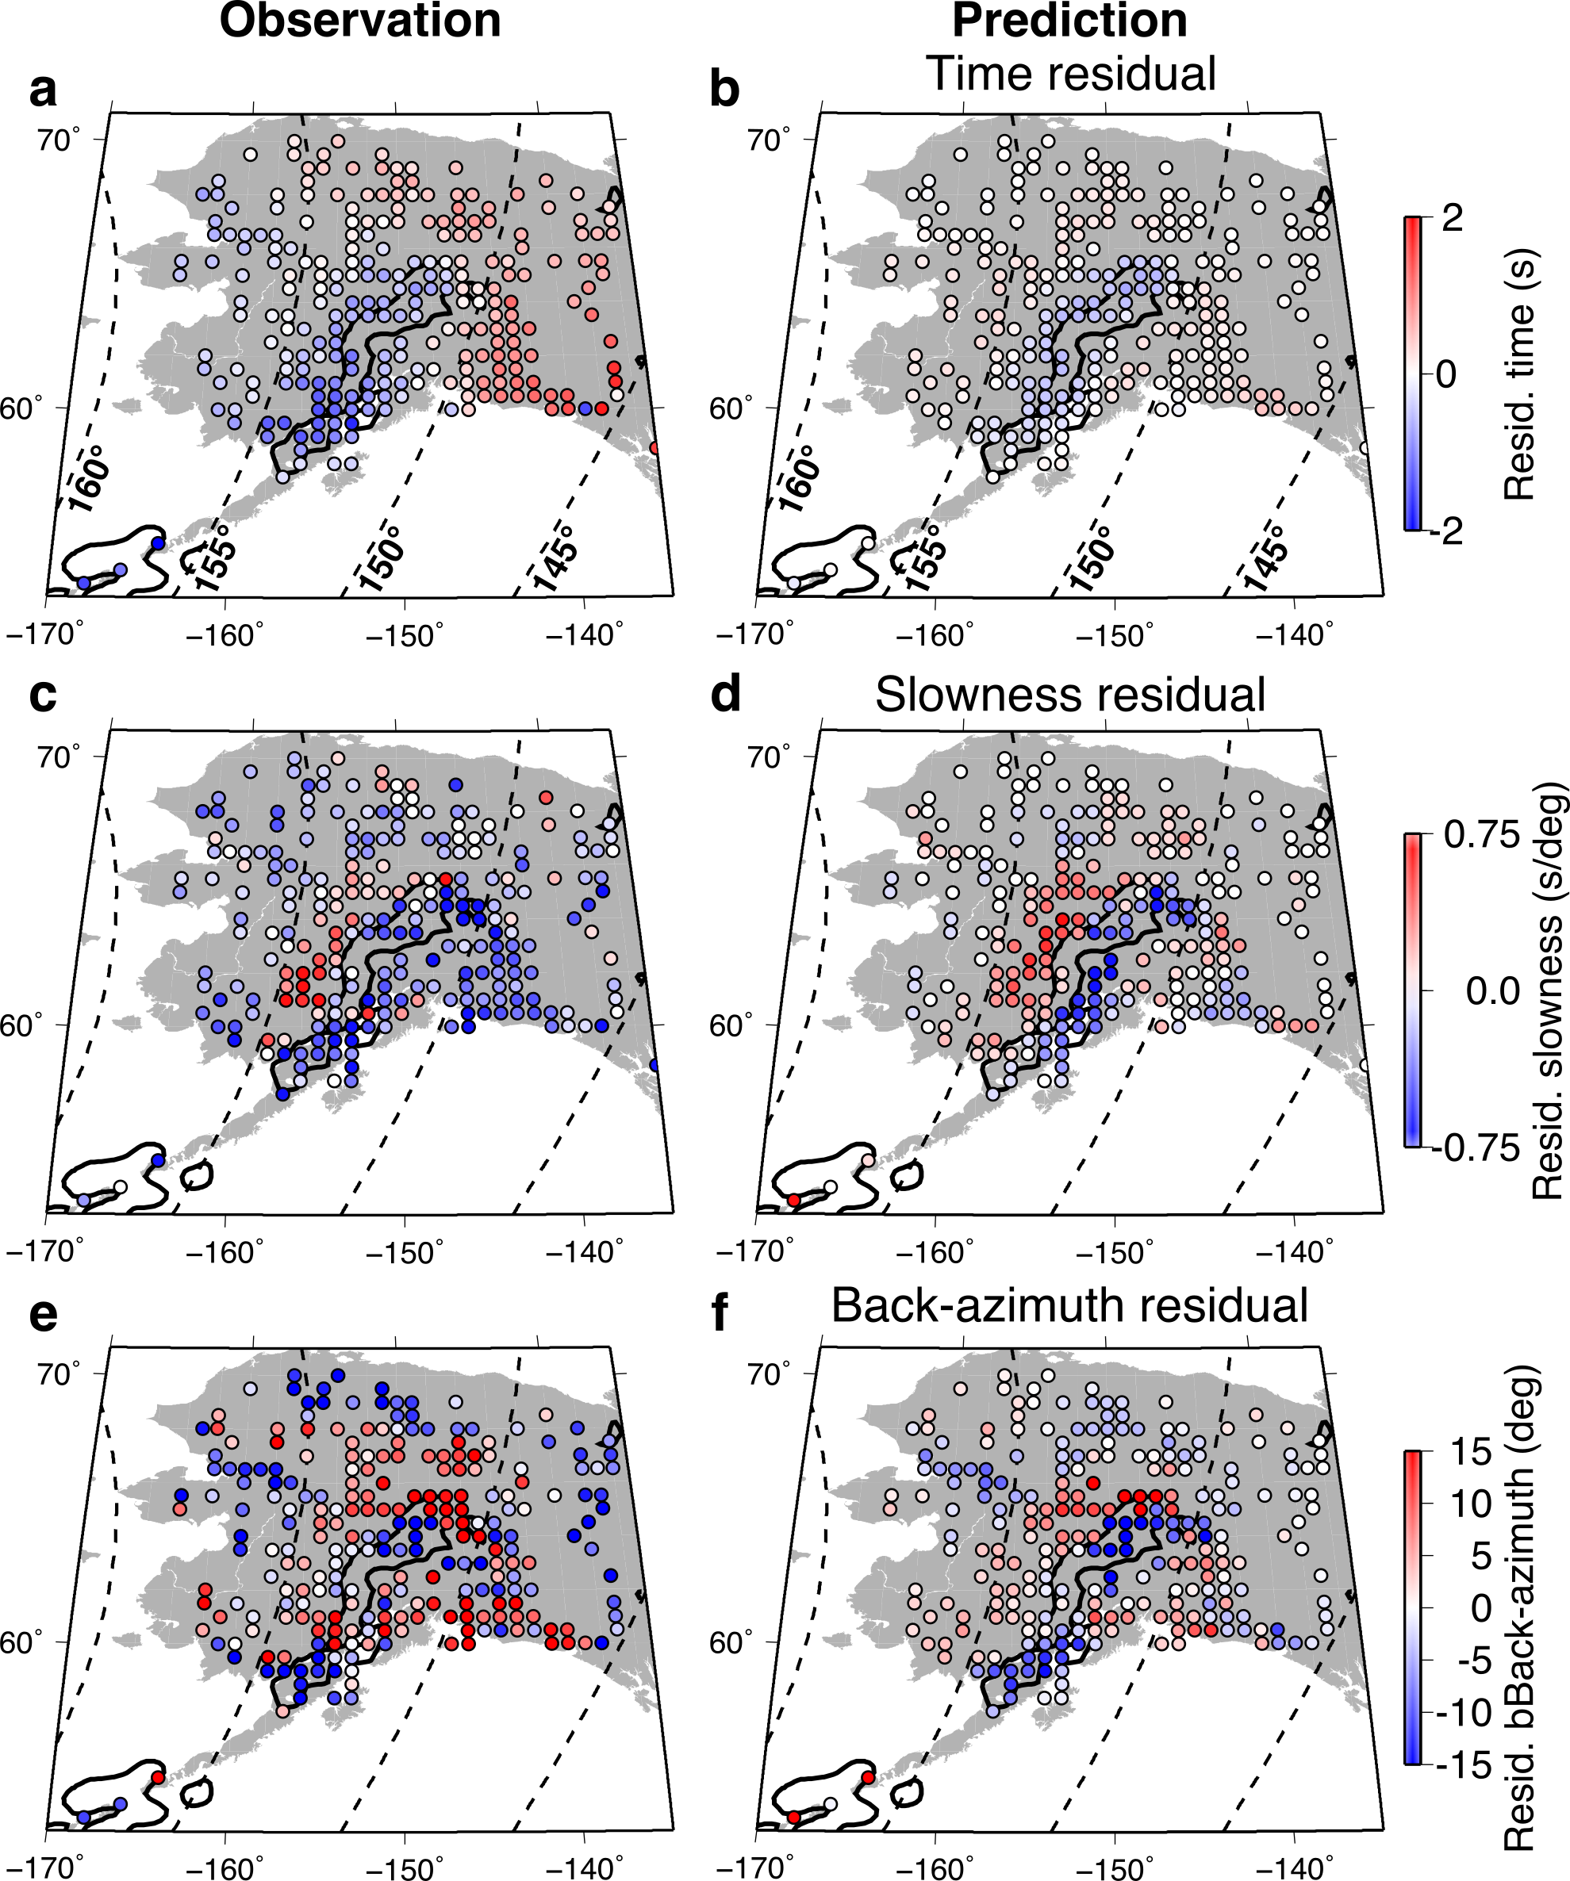
Supplementary Figure 5: Observed (left), predicted (right) absolute PKPdf ray anomalies from 3D ray-tracing through tomography model from Martin-Short et al., (2016), for all 6 events. (a, and b) Travel time residuals. (c and d) Slowness residuals. (e and f) Back-azimuth residuals. The outline of the Alaskan slab at 200 km depth (+0.8% dVp) from the preliminary tomography model is shown in black. The median observed absolute PKPdf travel time is subtracted from each event to account for origin time and location errors.

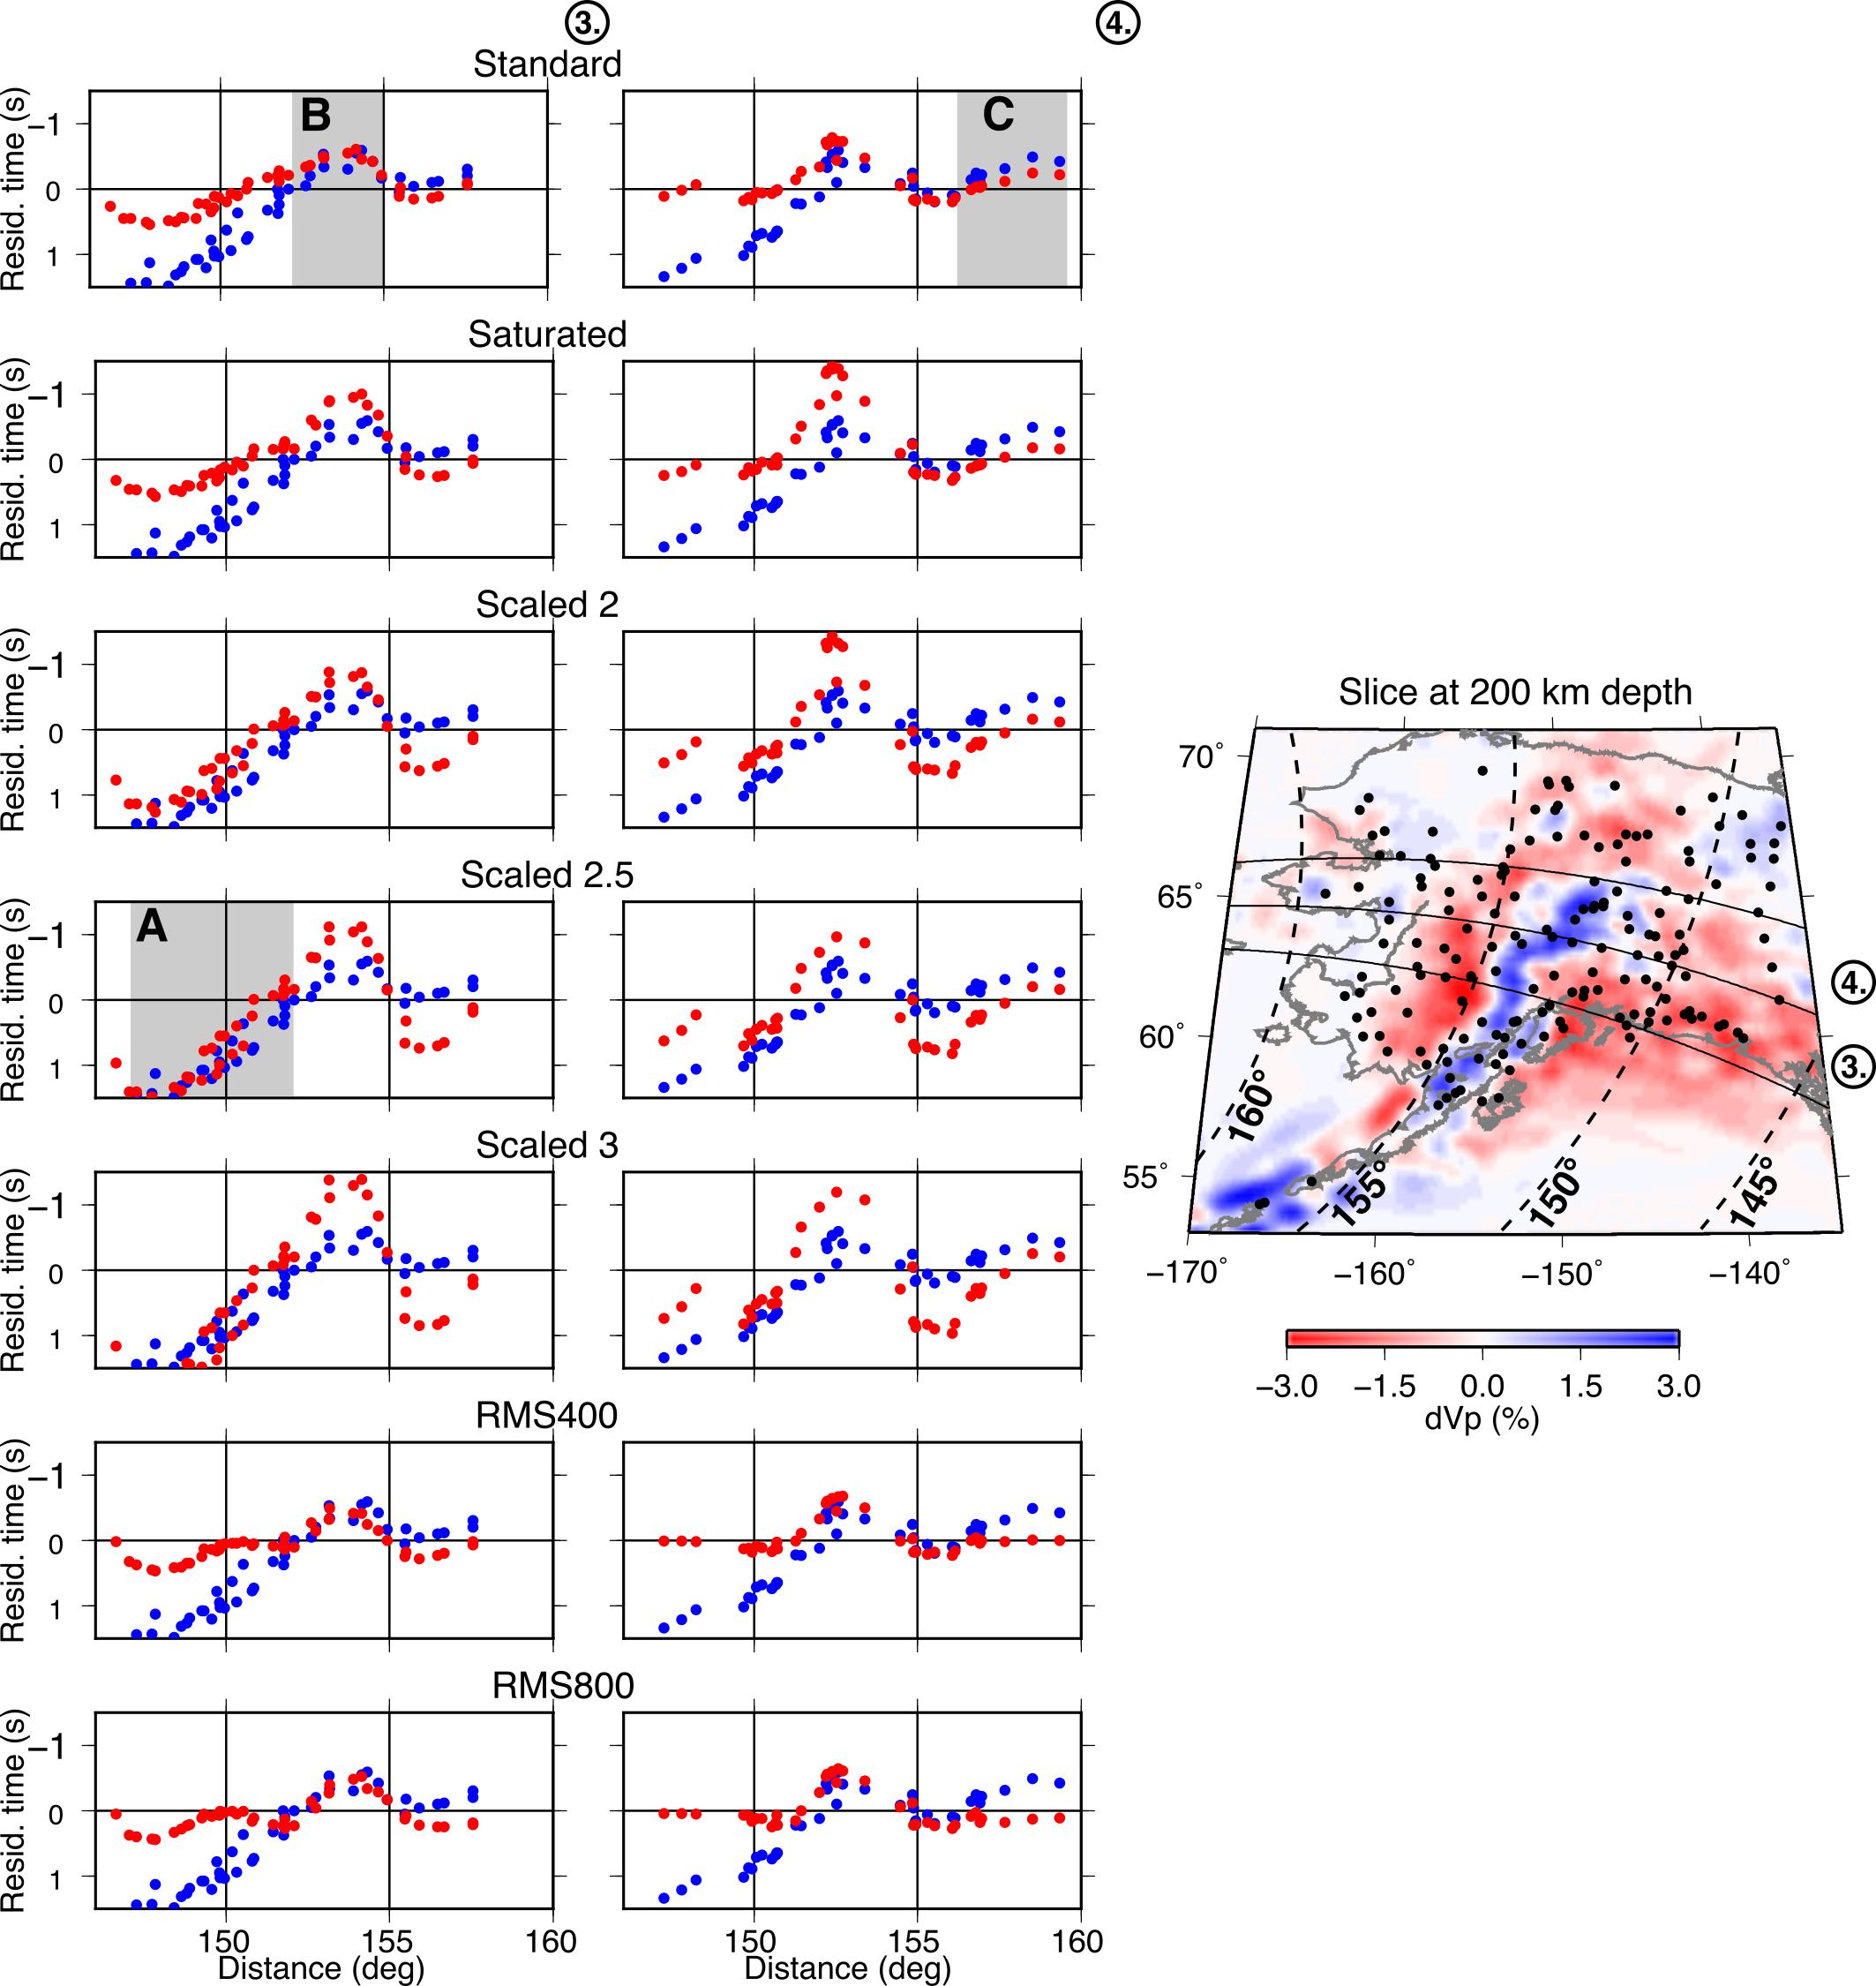
Supplementary Figure 6: Left: Absolute PKPdf travel time anomalies (blue) and predictions from different models (red) as a function of distance (i.e. moving from southeast to northwest across the slab) for event 6 on 2018-12-11 for two azimuth slices (labelled 3 and 4 as in Supplementary Figure 2). Right: Map of the upper mantle tomography model at 200 km depth, with stations shown as black circles. Azimuths sections shown on the left are labelled on the right, where color-scaled diamonds show distances along the section. Grey shading indicates locations mentioned in the main text and are shown on the model that best fits the observations: A – distances sampling the Yakutat showing positive travel time anomalies, best fit by model scaled by a factor of 2.5; B – sampling over the slab showing negative travel time anomalies, best fit by standard model; C – sampling at distances beyond the slab showing increasingly negative travel time anomalies with distance, not well fit by any model but best fit by standard model.

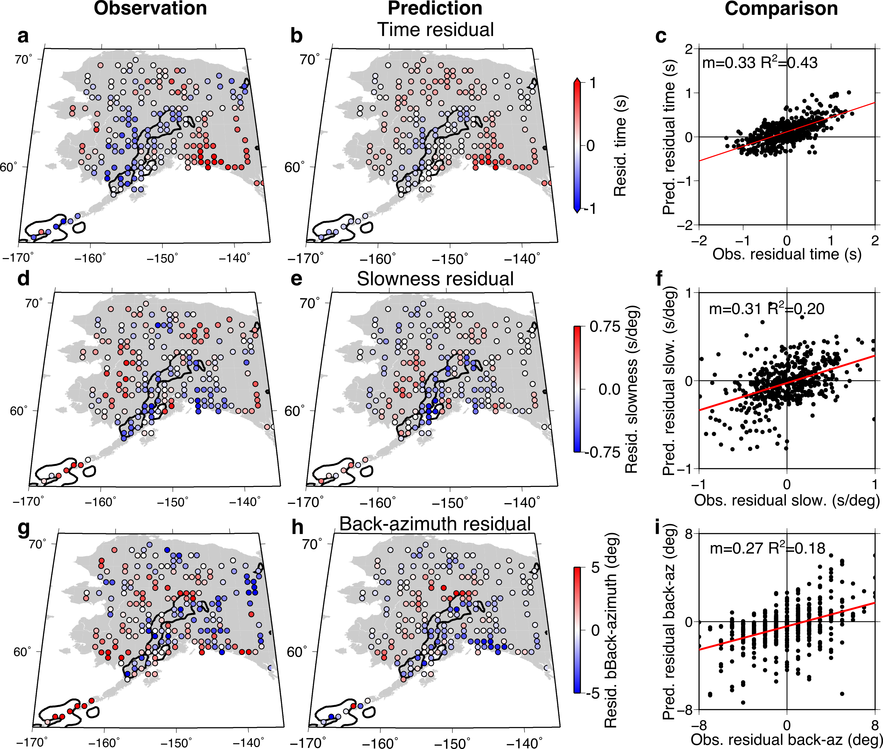
Supplementary Figure 7: Observed (left), predicted (middle) and comparison (right) of absolute teleseismic P wave ray anomalies from 3D ray-tracing through our preliminary tomography model of Alaska, for P wave 3 events (see Supplementary Table 3). (a, b and c): travel time residuals. (d, e, f): slowness residuals; (g, h, i) back-azimuth residuals. The outline of the Alaskan slab at 200 km depth (+0.8% dVp) from the preliminary tomography model is shown in black. The median observed absolute P wave travel time is subtracted from each event to account for origin time and location errors.

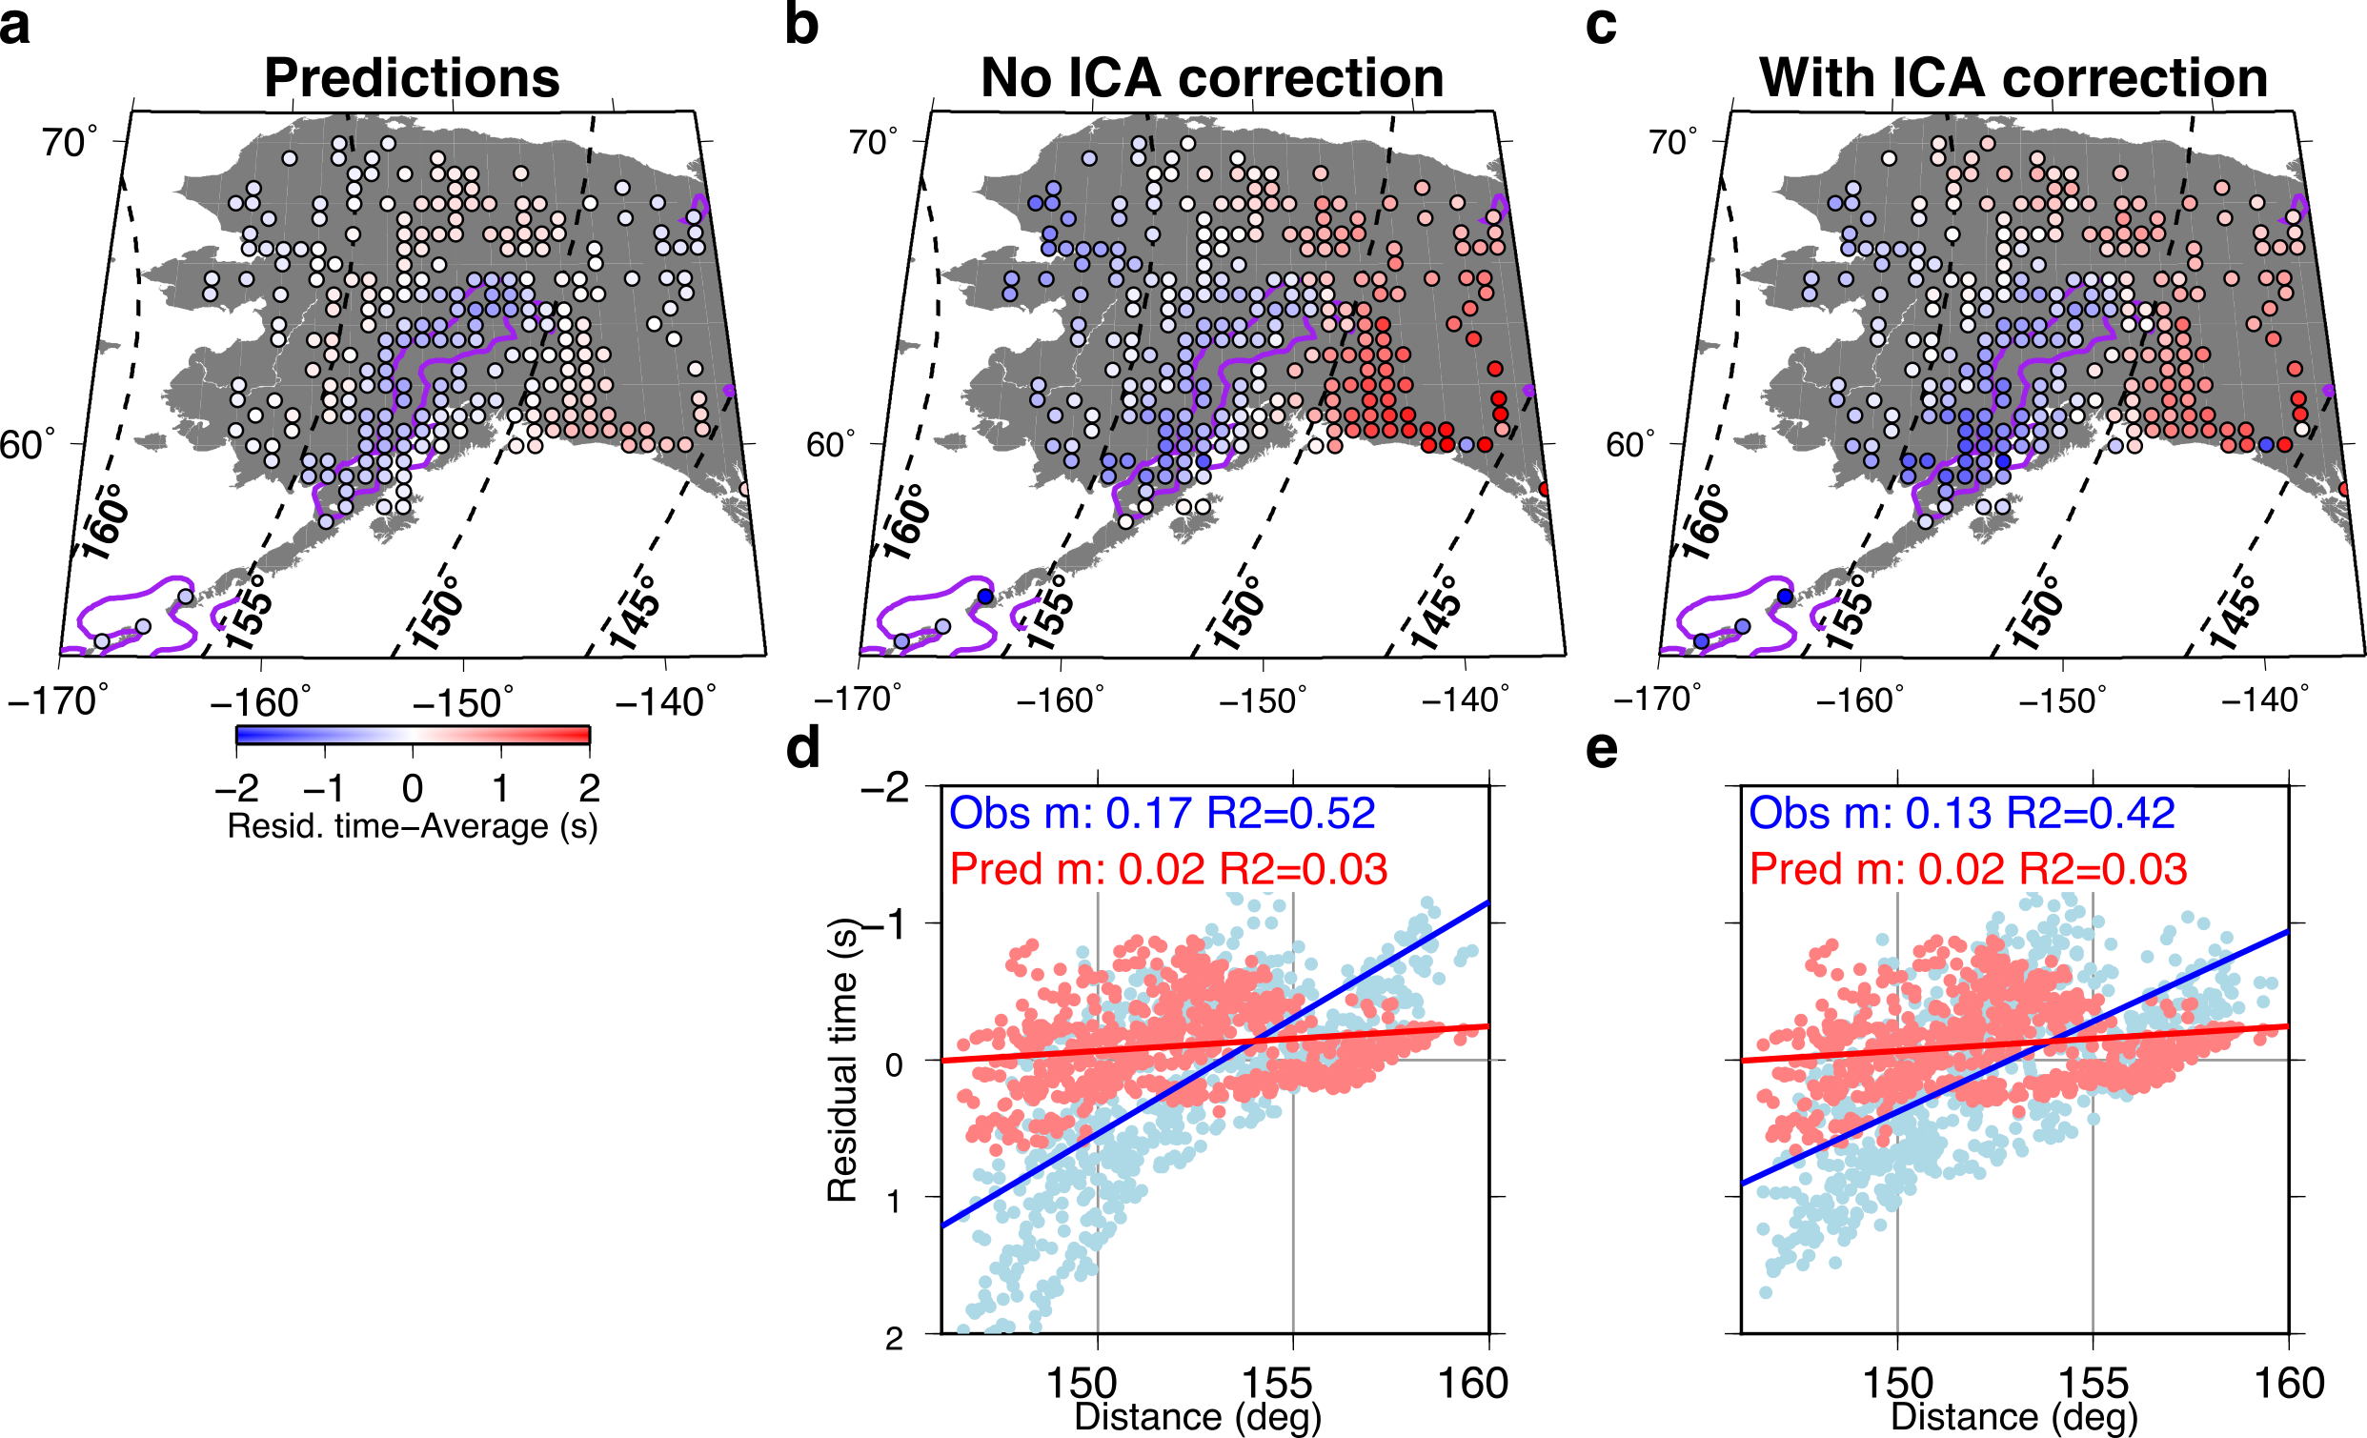
Supplementary Figure 8: Observed and predicted absolute PKPdf ray anomalies for all 6 events showing the effect of the ICA correction on the observations. (a) Predicted travel time anomalies from 3D ray-tracing through our preliminary tomography model of Alaska. PKPdf travel time anomalies as a function of location (b) without and (c) with the ICA correction. PKPdf travel time anomalies as a function of distance showing predictions in red and observations in blue (d) without the ICA correction and (e) with the ICA correction.

Supplementary Table 1: Source parameters of events used in this study for analysis of PKPdf waves. Locations from IRIS catalogue. The median residual time for each event likely represents errors in location or event timing since we use absolute PKPdf times without a reference.
Number | Event Date | Lat | Lon | Depth (km) | Magnitude | Median observed PKPdf residual (s)
1 | 2016-05-28 | -56.24 | -26.94 | 78.0 | 6.0 | 0.0
2 | 2016-08-21 | -55.28 | -31.75 | 10.0 | 6.4 | -1.5
3 | 2017-05-10 | -56.43 | -25.78 | 17.4 | 6.5 | 0.1
4 | 2017-09-04 | -57.79 | -25.58 | 35.0 | 6.0 | 0.1
5 | 2018-08-14 | -58.11 | -25.26 | 35.0 | 6.1 | -2.1
6 | 2018-12-11 | -58.60 | -26.47 | 163.7 | 7.1 | 3.8

Supplementary Table 2: Slopes (m) and R-squared fit (R²$=1-\left(\frac{\sum{(obs-pred)^{2}}}{\sum{(obs-\overline{obs})^{2}}}\right)$where 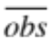 refers to the average of all observation) between observations and predictions for each event for different upper mantle tomography models. t refers to travel time residuals, u to slowness residuals and θ to back-azimuth residuals. SR refers to the standard model of Roecker et al., (2018), while RMS refers to the model of Martin-Short et al., (2016) cut at 400 km and 800 km depth, respectively. A slope of 1 indicates that the model predictions are of the same scale as the observations. For most events, the slowness and back-azimuth gradients reach 1 for models with lower scaling factors than necessary for the travel time gradient to reach 1. Red coloured text indicates the scaling factor for which the gradient (m) is closest to 1, and thus the predictions best match the observations.

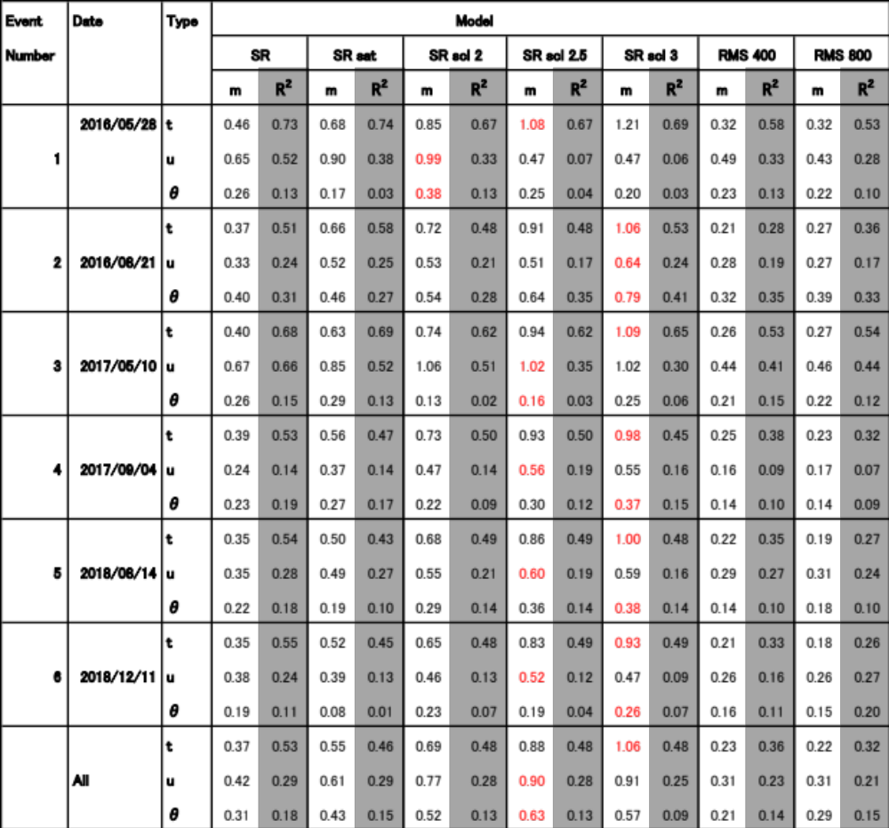
Supplementary Table 3: Source parameters of events used in this study for analysis of teleseismic P waves. Locations from IRIS catalogue. The median residual time for each event likely represents errors in location or event timing since we use absolute PKPdf times without a reference.
Number | Event Date | Lat | Lon | Depth (km) | Magnitude | Median observed P wave residual (s)
1 | 2018-01-10 | 17.47 | -83.52 | 10 | 7.5 | 4.3
2 | 2018-08-21 | 10.78 | -62.91 | 146.2 | 7.3 | 2.5
3 | 2019-09-24 | 19.08 | -67.27 | 10 | 6.0 | -1.4

